**Type 1 Technical Report template 2024**

**INITIATIVES**

**Annual Initiative-level report**

**TEMPLATE**

**Section 000: Cover page**

This section will be generated by PPU.

Please provide a high-resolution photo (and the photo credit and caption) for the cover.

* *Photos can be submitted into the* [designated Microsoft Teams folder](https://cgiar.sharepoint.com/:f:/r/sites/InitiativeDesignTeams/Shared%20Documents/Type%201%20Reports_2024?csf=1&web=1&e=pPWY3w) *available for Initiative files.*

Photo for cover page: [NPS_K17-NPS](https://cgiar.sharepoint.com/:i:/r/sites/InitiativeDesignTeams/Shared%20Documents/Type%201%20Reports_2024/INIT12_Nature-Positive%20Solutions/NPS_K17-NPS.jpg?csf=1&web=1&e=zKACXE)

Caption: NATURE+ collaborated directly with hundreds of farmers, including Elizabeth Omusiele, who was photographed at her farm in Lyanaginga Village in Kenya's Vihiga County. To increase her land’s agrobiodiversity, Omusiele planted local crop varieties, including amaranth, arrowroot, black nightshade, cowpea, jut mallow, and passion fruit. The artwork is part of a series developed by The Lexicon, which documented NATURE+ activities and developed a website to map the Initiative’s environmental and social benefits.

Credit: Artwork by Douglas Gayeton/The Lexicon Non-commercial use allowed with attribution.

**Section 00: Copyright information, citation details, disclaimers and acknowledgements**

This section will be generated by PPU.

**Table of contents**

This section will be generated by PPU.

**Section 0: CGIAR Technical Reporting 2024**

This section will be generated by PPU. It will include standard text on 2024 CGIAR Technical Reporting and an updated tech reporting diagram.

**Section 1: Fact sheet, executive summary and budget**

Max. length: 2 pages (including Initiative budget)

|  |  |
| --- | --- |
| **Fact sheet** | |
| **Initiative name** | Nature-Positive Solutions for Shifting Agrifood Systems to More Resilient and Sustainable Pathways |
| **Initiative short name** | Nature-Positive Solutions |
| **Initiative lead** | Carlo Fadda - [c.fadda@cgiar.org](mailto:c.fadda@cgiar.org) |
| **Initiative Co-lead** | Solomie Gebrezgabher - [s.Gebrezgabher@cgiar.org](mailto:s.Gebrezgabher@cgiar.org) |
| **Science Group** | Resilient Agrifood Systems |
| **Start date** | 01/04/2022 |
| **End date** | 31/03/2025 |
| **Geographic scope** | **Regions:**  *This Initiative does not have regions targeted in the proposal*  **Countries:** Burkina Faso; Colombia; India; Kenya; The Socialist Republic of Viet Nam |
| **OECD DAC Climate marker Adaptation score\*** | **Score 1** Significant: The activity contributes in a significant way to any of the three CGIAR climate-related strategy objectives – namely, climate mitigation, climate adaptation, and climate policy, even though it is not the principal focus of the activity. |
| **OECD DAC Climate marker Mitigation score\*** | **Score 1** Significant: The activity contributes in a significant way to any of the three CGIAR climate-related strategy objectives – namely, climate mitigation, climate adaptation, and climate policy, even though it is not the principal focus of the activity. |
| **OECD DAC Gender equity marker score\*** | **Score 1A** Gender accommodative/aware: Gender equality is an objective, but not the main one. The Initiative/project includes at least two explicit gender specific outputs and (adequate) funding and resources are available. Data and indicators are disaggregated by gender and analyzed to explain potential gender variations and inequalities. |
| **Links to webpage** | <https://www.cgiar.org/initiative/12-nature-positive-solutions-enhancing-productivity-and-resilience-safeguarding-the-environment-and-promoting-inclusive-community-growth/> |

|  |
| --- |
| 1The Organisation for Economic Co-operation and Development (OECD) Development Assistance Committee (DAC) markers refer to the OECD DAC [Rio Markers for Climate](https://www.oecd.org/dac/environment-development/Revised%20climate%20marker%20handbook_FINAL.pdf) and the [gender equality policy marker](https://www.oecd.org/dac/gender-development/thedacgenderequalitypolicymarker.htm).  2For climate adaptation and mitigation, scores are: 0 = Not targeted; 1 = Significant; and 2 = Principal.  3The CGIAR GENDER Impact Platform has adapted the OECD gender marker, splitting the 1 score into 1A and 1B. For gender equality, scores are: 0 = Not targeted; 1A = Gender accommodative/aware; 1B = Gender responsive; and 2 = Principal.  These scores are derived from [Initiative proposals](https://www.cgiar.org/how-we-work/governance/system-council/initial-set-of-submissions-for-the-cgiar-2022-2024-investment-prospectus/), and refer to the score given to the Initiative overall based on their proposal. |
| **Executive summary**  From 2022 to 2024, the Nature-Positive Solutions (Nature+) Initiative delivered significant scientific, policy, and community-level outcomes to embed biodiversity conservation and sustainability in agricultural systems. Through a combination of co-created innovations, transdisciplinary research, and multistakeholder partnerships, the Initiative contributed meaningfully to CGIAR's 2022–2024 research portfolio and laid the foundation for broader transformation across food, land, and water systems for CGIAR's Research Portfolio for 2025–2030.  **Key achievements**  *Advancing nature-positive science*  NATURE+'s FIVE Work Packages (WPs) were designed, deployed, and integrated into a holistic vision of nature-positive research and implementation. Centered on the sustainable use and conservation of biodiversity, NATURE+ integrated farming and circular economy systems for enhanced restoration, food and nutrition security, and livelihoods. The Initiative included soil management and research on its microbiome to develop site-specific soil needs for increased productivity. NATURE+ researched True Cost Accounting (TCA) to calculate and inform stakeholders about the unaccounted-for social and environmental costs of food systems, a key challenge that must include policy action to achieve sustainability. The Initiative collected gender-disaggregated data on nature-positive activity to inform nature-positive implementation and policies.  NATURE+ developed innovations aimed at identifying and using a greater diversity of crops, trees, and forages—with a focus on native species and varieties—in close collaboration with communities. These included **VarScout** and the **Seeds for Needs** approaches to identify crops and varieties, **Diversity for Restoration** (D4R) for identification of suitable native tree species for restoration and integration of agroforestry, and community seed banks and the **My Farm Trees** platform to guide and financially incentivize tree-based landscape restoration.  To improve the circularity of the systems, the Initiative identified financially viable opportunities to manage waste aligned with community needs, waste types and nature-positive business development and cost reductions for farmer inputs. Waste-based products included biogas and briquettes for bioenergy and black soldier fly farming for bio-fertilizer and low-cost, high-protein feed for farm animals.  The Initiative worked with farmers to strengthen market-oriented mindsets and embrace economies of scale. Key successes included farm aggregation in Kenya and the creation of – or guidance for growth of – successful circular bioeconomy businesses.  Across its five WPs, NATURE+ successfully developed and enhanced tools, technologies, and knowledge products to support nature-positive outcomes. The use of participatory, farmer-led approaches ensured these tools were relevant and adopted by end users, with measurable improvements in sustainability, equity, and productivity.  *Strong progress toward End of Initiative Outcomes (EOIOs)*  All five EOIOs met or exceeded their targets, demonstrating meaningful progress. NATURE+ engaged more than 100,000 farmers with nature-positive solutions. Influenced by NATURE+, policymakers in at least five countries supported nature-positive policy reforms and several national agricultural institutions adopted biodiversity-enhancing methodologies. Investment actors integrated nature-positive frameworks into decision-making. These results reflect the Initiative's strong on-ground activity, government collaboration, and the appeal of nature-positive agriculture to public and private sectors.  *Country-level impact*  NATURE+ was implemented in Viet Nam, Kenya, India, Colombia, and Burkina Faso. Highlights include:   * **Viet Nam**: Promotion of, and research on, traditional crops in collaboration with rural, Indigenous and women's networks. * **Kenya**: Establishment of aggregated farms, permaculture cooperatives, and deployment and of innovative reforestation tools with close community collaboration. * **India**: Strengthening of traditional seed banks, integration of tribal knowledge and deployment of several nature-positive agriculture innovation bundles; applicable research on native tree varieties. * **Colombia**: Transition from extractive farming to nature-positive practices and adoption; sustainable use and conservation of neglected and underutilized species; nationwide enhancement of circular bioeconomy activity through "boot camps" and government collaboration. * **Burkina Faso**: Grassroots agroecological frameworks built through partnerships with women’s groups and schools; detailed research on 600 small-scale nurseries to improve reforestation initiatives.   These in-country efforts ensured context-specific implementation while reinforcing cross-country learning.  *Partnership-driven transformation*  NATURE+ collaborated with more than 100 external (non-CGIAR) partners, including governments, NARES, civil society, private sector actors, and international organizations. Partnerships were central to the collaborative development of innovations and policy recommendations. The Initiative advanced circular bioeconomy (CBE) activity through close collaboration with women's cooperatives, entrepreneurs and government organizations advancing national circular economy goals. NATURE+ CBE partnerships in all five Initiative target countries improved waste management, biodiversity and livelihoods. Initiative activities influenced global dialogues, and in some cases program implementation, related to nature-positive agriculture. (Organizations include the FAO, UNDP, UNEP and the Convention on Biological Diversity).  *2024 Highlights*  In its final year, NATURE+ deepened policy engagement and local implementation. Several countries aligned agricultural policies and strategies with nature-positive principles. NATURE+ and partners scaled innovations across regions, particularly digital tools for landscape restoration and agrobiodiversity identification and use. The Initiative increased the integration of gender and equity factors into program design and evidence generation.  *Conclusion*   * NATURE+ demonstrated that **nature-positive agricultural transitions are feasible, profitable and beneficial for people and nature** when grounded in science and driven by partnerships. * The **integration of biodiversity conservation, circular economy, and equity** into agrifood systems delivers **benefits for people and the planet**. * **Community-led innovation and knowledge systems are central to nature-positive successes**, with tools and practices co-developed with community stakeholders. * **Policies and investments for nature-positive solutions** are catalyzed through **strategic partnerships and evidence-based engagement**.   At the conclusion of the Initiative's first phase, NATURE+ delivers a strong foundation for continued growth for its portfolio of innovations, a tested model of transdisciplinary collaboration, and a clear direction for scaling nature-positive solutions across regions and systems. The momentum generated by the Initiative is fully expected to be critical to the success of Multifunctional Landscapes Science Program and the CGIAR Research Portfolio 2025-2030. |

**Budget**

|  |  |  |  |
| --- | --- | --- | --- |
| US$ | 2022 | 2023 | **2024** |
| Proposal budget | $6,618,670 | $8,566,576 | $9,920,427 |
| Approved budget | $4,430,996 | $6,380,774 | $6,500,000 |

**Section 2: Progress towards End of Initiative outcomes**

Photos for section 2:

Option 1 [For WP4 report cover_cropped-1.jpg](https://cgiar.sharepoint.com/:i:/r/sites/InitiativeDesignTeams/Shared%20Documents/Type%201%20Reports_2024/INIT12_Nature-Positive%20Solutions/For%20WP4%20report%20cover_cropped-1.jpg?csf=1&web=1&e=UlmWYc)

Caption: Women in Manyatta, in Kenya’s Kisumu County, show off their improved cooking briquettes made from organic waste. In collaboration with NATURE+, the women formed a cooperative to produce better briquettes with equipment and training provided by the International Water Management Institute, which co-led the Initiative. Previously, the women made lower-quality briquettes that sold for less. Their new, independent organization demonstrates how waste can be converted into wealth and create circular bioeconomy opportunities for marginalized people and communities.

Credit: Edwin Okoth for NATURE+

Option 2: [For WP1_option2-.jpg](https://cgiar.sharepoint.com/:i:/r/sites/InitiativeDesignTeams/Shared%20Documents/Type%201%20Reports_2024/INIT12_Nature-Positive%20Solutions/For%20WP1_option2-.jpg?csf=1&web=1&e=pQH0fE)

The Chinguad family, custodians of agrobiodiversity in Cumbal, Colombia, demonstrate several local landraces they preserve and cultivate, including potatoes, mashua, oca and other roots and tubers. The family also cultivates several medicinal plants. Families like the Chinguad’s collaborated with NATURE+ to take stock of local agrobiodiversity and establish a community seedbank.

Credit: Courtesy of Stef de Haan/International Potato Center

**Initiative-level theory of change diagram**

This is a simple, linear, and static representation of a complex, non-linear, and dynamic reality. Feedback loops and connections between this and other Initiatives’ theories of change are excluded for clarity.

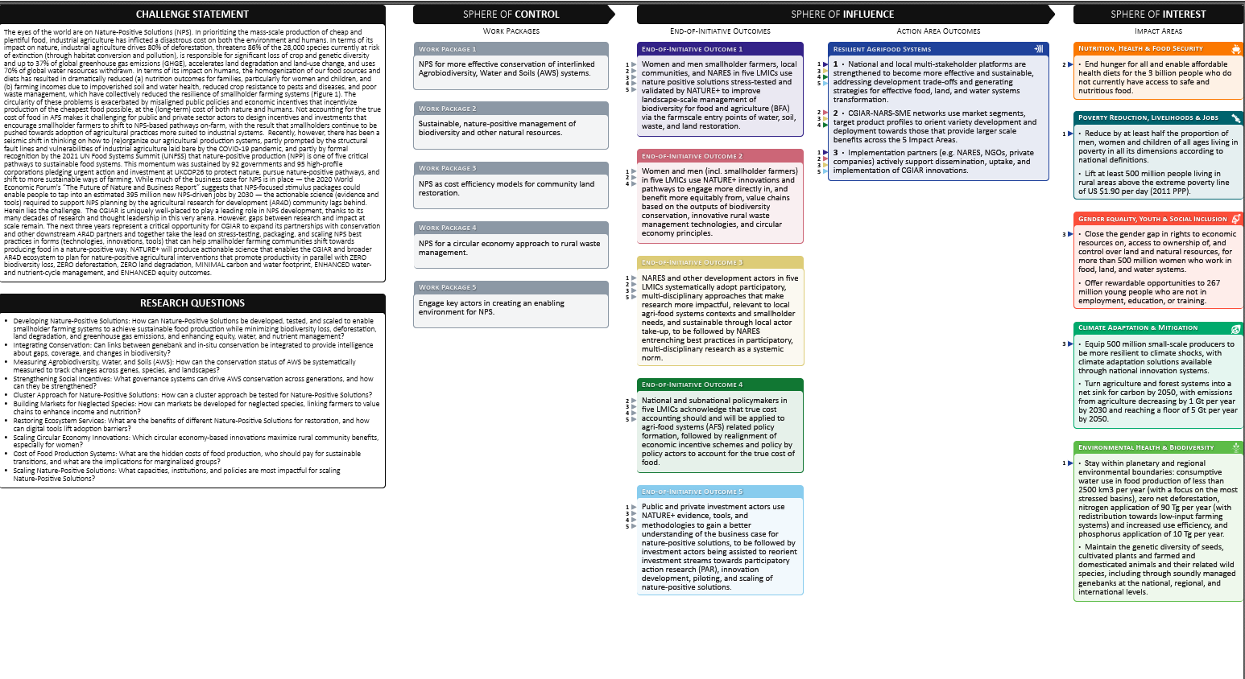

**Summary of progress against the theory of change**

In 2022-2024, the Nature-Positive Solutions Initiative made significant advances in scientific research and achieved measurable impacts across multiple geographies. By fostering participatory engagement with farmers, policymakers, research institutions, and investors, the Initiative contributed to increased adoption of sustainable agricultural practices and biodiversity conservation. This report summarizes key achievements in scientific progress and the accomplishment of End of Initiative Outcomes (EOIOs), highlighting 2024 milestones and reflecting on the Initiative’s effectiveness in addressing its core challenges.

**Scientific progress**

The Initiative successfully developed and disseminated innovative tools, methodologies, and frameworks that enhance the resilience of agricultural landscapes. Some key scientific contributions include:

* + **Deployment of, and research to enhance, digital innovations** (EOIO 1): NATURE+ researchers added detailed functional trait data on hundreds of native tree species to the Diversity for Restoration platform; this information helps identify native tree species are aligned with community restoration priorities and were bundled with the My Farm Trees app, which guided and financially rewarded thousands of smallholders for successfully planting seedlings, and continues to grow in demand. Additionally, NATURE+ collaborated on the expansion of VarScout to Kenya. The tool enables farmers to select crop varieties best suited to climate variability, adopted by over 5,000 Kenyan farmers and extension personnel.
  + **Citizen science for agrobiodiversity research** (EOIO 2): NATURE+ researchers worked with farmers to collect data on the growth and yield of several neglected and underutilized crop species (NUS). The field data complemented genetic analysis of the crop varieties to understand the drivers of the crops' traits, including resilience to climate change and benefits to nature-positive agriculture. A digital app (ClimMob) was used for this purpose.
  + **Biodiversity monitoring frameworks** (EOIO 3): A transdisciplinary approach to tracking biodiversity improvements in agroecosystems, widely used by national research institutions (NARES).
  + **True cost accounting for policymaking** (EOIO 4): NATURE+ researchers collected detailed data on the true economic and social costs of food in Viet Nam and Kenya. By putting a price tag on the externalities – which are generally negative impacts on society and the environment – the information is expected to lead to policy proposals to guide key actions required to mitigate the harm food production causes to people and nature.
  + **Investment partnerships** (EOIO 5): Strengthening the engagement of private sector actors in financing nature-positive innovations, leading to increased financial commitments to sustainable agricultural models. The World Bank grant aimed at identifying impact on biodiversity from agriculture and the finding will potentially drive investment toward more nature positive solutions.
  + **Soil research:** the Initiative supported soil health improvements through integrated watershed management and landscape restoration approaches, particularly in India and Viet Nam, addressing degradation and enhancing ecosystem resilience.
  + **Value chains:** Nature+ worked with local communities to identify opportunities for scaling nature-positive products, particularly neglected and underutilized species (NUS), and informed market-based strategies for biodiversity-friendly agriculture.
  + **BSF and aggregated farms work:** Nature+ facilitated the uptake of Black Soldier Fly (BSF) farming in Kenya and Burkina Faso for sustainable animal feed, while aggregated farms in Kenya served as cooperative hubs for implementing nature-positive practices at scale.
  + **Policy development:** The Initiative contributed to the development and uptake of policy proposals incorporating true cost accounting and biodiversity incentives, with adoption and piloting seen in countries like Kenya, Colombia, and Viet Nam.

**Progress against End of Initiative outcomes**

The Initiative successfully met or exceeded its expected targets for all EOIOs, demonstrating its effectiveness in translating scientific advancements into tangible outcomes. Notable achievements include:

* + EOIO 1: Over 100,000 smallholder farmers and extension agents have adopted nature-positive solutions, leading to improved crop resilience and productivity. The figure includes users of the My Farm Trees app, participants in nature-positive demonstration and aggregated farms, citizen science contributions made by farmers to various research outputs, engagement and training of entrepreneurs and farmers in circular bioeconomy and value chain activities.
  + EOIO 2: The widespread use of participatory research approaches has enhanced farmer-led innovation in agricultural practices.
  + EOIO 3: At least five national research institutions have institutionalized nature-positive methodologies, ensuring sustainability beyond the Initiative’s timeline. Co-development of locally tailored solutions has been realized through collaborations with UNDP, the National Museums of Kenya, the Kenya Agricultural and Livestock Research Organization, the Ministry of Agriculture and Livestock Development (Kenya), Slow Food, and WWF.
  + EOIO 4: Policymakers in five countries have utilized True Cost Accounting data to inform policy reforms, identifying the unpaid costs the food system offloads on society and the environment, and leading to enhanced support and policy work for sustainable land use practices.
  + EOIO 5: Nature-positive investment frameworks have been mainstreamed in regional and global financial initiatives, securing long-term funding for biodiversity-friendly agricultural transitions.

**EOIO 1:** Women and men smallholder farmers, local communities, and NARES in five LMICs use nature positive solutions stress-tested and validated by NATURE+ to improve landscape-scale management of biodiversity for food and agriculture (BFA) via the farm-scale entry points of water, soil, waste, and land restoration.

Over three years, NATURE+ engaged more than 100,000 smallholder farmers and NARES to accelerate the adoption of nature-positive innovations. By deploying all WPs at shared sites, the Initiative strengthened community participation, co-developed context-specific solutions, and fostered sustainable agricultural practices.

NATURE+ promoted innovations across all pillars of nature-positive systems, tailoring packages to local needs in five target countries. These included technical tools to identify and deploy native trees, local landraces, and NUS for improved nutrition, reduced reliance on industrial inputs, and enhanced food security. The Initiative also advanced soil management research and promoted circular economy models aligned with community and government priorities.

In all countries, farmers used the Seeds for Needs approach or the VarScout tool to identify NUS and climate-resilient crop varieties, accessing planting material through farmer-led systems and seed banks. Forage trials in Colombia, Kenya, and Viet Nam improved livestock nutrition and restored degraded land.

More than 5,000 farmers planted trees using the D4R and My Farm Trees platforms. Over 11,000 engaged with circular bioeconomy innovations. Games-based research generated gender-disaggregated insights, empowered marginalized groups, and fostered cooperation—key to establishing aggregated farms.

**EOIO 2:** Women and men (including smallholder farmers) in five LMICs use NATURE+ innovations and pathways to engage more directly in, and benefit more equitably from, value chains based on the outputs of biodiversity conservation, innovative rural waste management technologies, and circular economy principles.

More than 11,000 smallholders economically benefited from the adoption of NATURE+ innovations. The Initiative applied a range of strategies to strengthen farmer livelihoods while protecting the natural ecosystems they rely on. It developed 12 value chains across its target countries, reaching 932 direct beneficiaries by 2024, with clear signs of continued growth. Farmers involved in community seed banks also gained from newly established business plans that support long-term sustainability. As coordination around the production and marketing of the 12 commodities improves, these value chains are expected to benefit many more farmers. In Kenya, farmers began testing the aggregated farm model, which has yet to yield the anticipated economic results but continues to evolve. In Burkina Faso and Kenya, farmers accessed tree nurseries developed through NATURE+, which provided both income and restoration benefits. In Burkina Faso alone, the Initiative and its partners studied 600 small-scale tree nurseries to build local capacity and support reforestation more effectively. Circular economy models also delivered strong economic benefits. NATURE+ helped establish 17 small and medium-sized enterprises (SMEs) focused on waste-to-resource innovation, creating new livelihood opportunities while promoting environmental sustainability.

**EOIO 3:** NARES and other development actors in five LMICs systematically adopt participatory, multidisciplinary approaches that make research more impactful, relevant to local agrifood systems contexts and smallholder needs, and sustainable through local actor take-up, to be followed by NARES entrenching best practices in participatory, multidisciplinary research as a systemic norm.

NATURE+ forged cross-country partnerships with leading development actors and national agricultural research and extension systems (NARES) in the target countries. In all countries, the Initiative worked with the NARS, including Agrosavia in Colombia, KALRO in Kenya, INERA in Burkina Faso, VAAS in Viet Nam and ICAR in India. As co-implementers of a number of activities, these centers were involved in participatory activities, including the use of citizen science tools. In addition, the Initiative also partnered with other relevant development partners, including UNDP, the National Museums of Kenya, Slow Food, Mani Tese (an Italian NGO), IUCN, GEF, and WWF, among others on different aspects of the Initiative.

**EOIO 4:** National and subnational policymakers in five LMICs acknowledge that true cost accounting should and will be applied to agrifood systems (AFS) related policy formation, followed by realignment of economic incentive schemes and policy by policy actors to account for the true cost of food.

NATURE+ collected true cost accounting data and discussed results with stakeholders in Kenya and Viet Nam. These included the Vietnamese Academy of Agricultural Sciences and several government departments in Viet Nam, and several departments from the County Governments of Kisumu and Vihiga in Kenya as well as the State Department for Gender and Affirmative Action and the Intersectoral Forum on Agrobiodiversity and Agroecology. In addition, researchers worked closely with True Cost Accounting (TCA) Accelerator, True Price, and Rockefeller Foundation to present a session on TCA at Sixteenth Meeting of the Conference of the Parties to the Convention on Biological Diversity (COP 16) in Cali, Colombia. NATURE+ was approached by the World Bank to present a seminar on true cost accounting for the "Biodiversity and Agriculture" webinar series. NATURE+ was very active in engaging with policymakers. Notably, the Initiative engaged on seed policy development in Kenya to facilitate the use of agrobiodiversity and contributed to building business cases for community seed banks. The Initiative contributed to the development of an Agroecology Policy in Vihiga County, in Kenya. In Viet Nam, NATURE+ is part of the government's food system transformation strategy.

**EOIO 5:** Public and private investment actors use NATURE+ evidence, tools, and methodologies to gain a better understanding of the business case for nature-positive solutions, to be followed by investment actors being assisted to reorient investment streams toward participatory action research (PAR), innovation development, piloting, and scaling of nature-positive solutions

NATURE+ innovations and participatory models attracted the attention of new partners and countries, fostering collaborations and funding commitments, namely from UNEP and the World Bank, which provided funds for assessing the effectiveness of NATURE+ practices, including the positive impacts of agriculture on biodiversity based on NATURE+ approaches. In addition, the Initiative's designated funds grew each year, demonstrating donors' interest in supporting nature-positive research and implementation.

Additionally, the Initiative promoted greater engagement in nature-positive economic activities, both through engaging private actors and by developing rural entrepreneurship and the establishment of SMEs. Community seed banks were developed with business plans to ensure they can develop into sustainable enterprises. Similarly, NATURE+'s circular economy work supported the development of 17 businesses in the 5 countries.

**Addressing core challenges**

The Initiative set out to tackle key challenges related to climate resilience, biodiversity loss, and the integration of sustainability into agricultural policies and investments. The following reflections illustrate the impact of the Initiative’s efforts:

* + Bridging the science-implementation gap: By fostering co-creation processes with local stakeholders, the Initiative ensured that scientific research translates into actionable, community-driven solutions.
  + Institutionalizing sustainable practices: The uptake of nature-positive approaches by national research institutions and policymakers suggests a systemic shift toward more sustainable agricultural governance.
  + Scaling financial commitments: Engaging with investment actors has helped secure long-term funding mechanisms that will sustain nature-positive transitions beyond the Initiative’s business cycle.

**Conclusion**

The Nature-Positive Solutions Initiative successfully delivered on its theory of change by combining scientific innovation with strategic policy and financial engagements. As the Initiative reaches the end of its current cycle, its legacy is evident in the institutional and financial commitments secured to sustain nature-positive practices at scale. Future efforts in the CGIAR Research Portfolio 2025-2030 should build on these achievements by further integrating digital innovations, expanding farmer-led research networks, deepening policy engagement to ensure long-term impact, and expanding to the landscape scale, both in NATURE+ target countries and others.

**Section 3: Work Package progress**

**Work Package 1: CONSERVE**

Theory of change diagram:

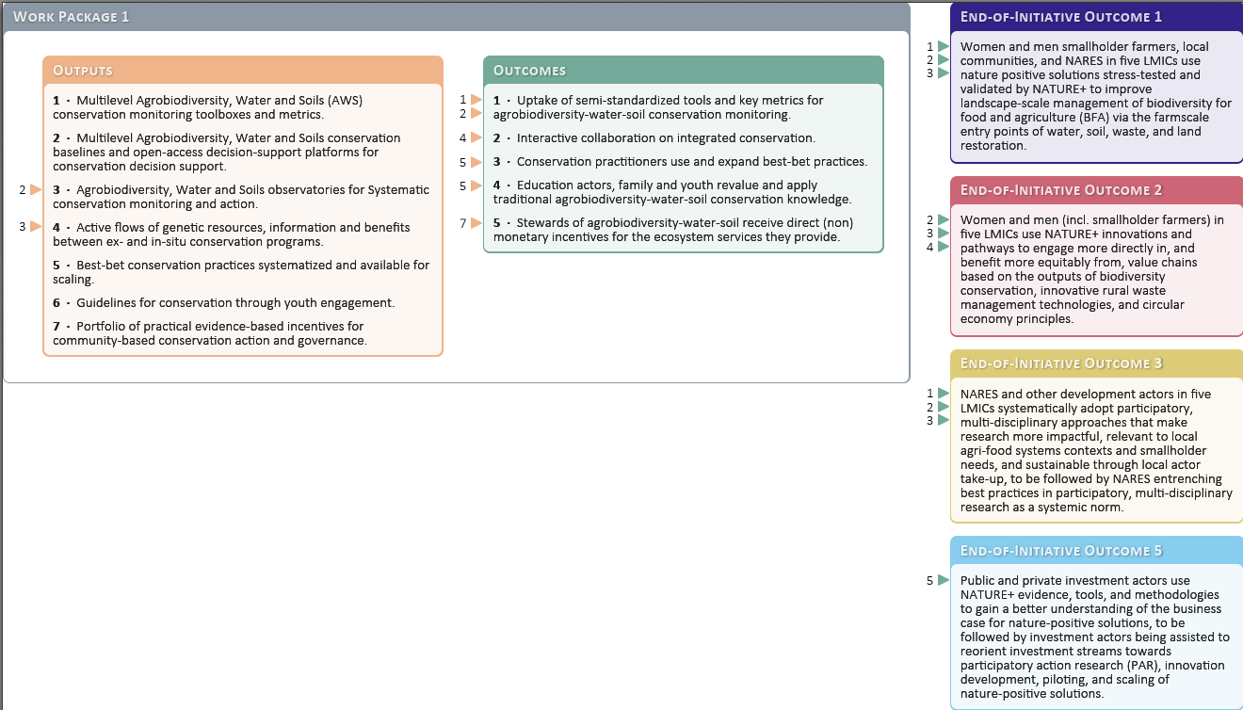

**Progress against the theory of change**

The Nature-Positive Solutions Initiative made significant progress in conserving agrobiodiversity by establishing community seed banks, promoting traditional knowledge, and strengthening nature-positive farming practices. These efforts helped safeguard genetic diversity, improve food security, enhance resilience to environmental changes, and increase the sustainable use of agrobiodiversity across multiple regions.

**Work Package 2: MANAGE**

Theory of change diagram:

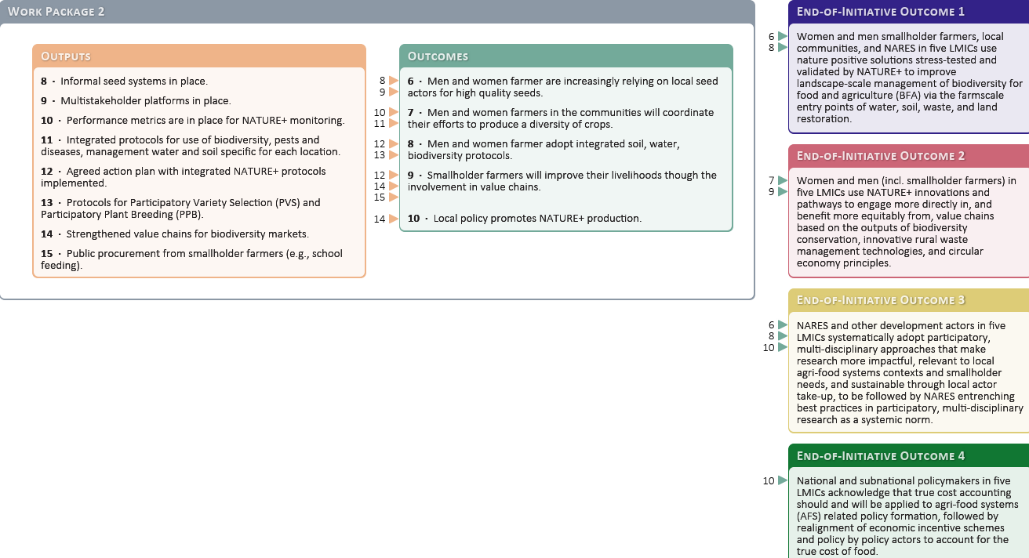

**Progress against the theory of change**

WP2 focuses on the simultaneous deployment of several technological innovations at research sites. These comprehensive interventions cover biodiversity, soil and water management. In addition, the WP focuses on ensuring that value chains and other livelihood-supporting strategies are improved.

More information about the value chain development approach can be found [here](https://storage.googleapis.com/cgiarorg/2025/02/NATURE-Value-Chains-Report-2022-2024.pdf).

**Work Package 3: RESTORE**

Theory of change diagram:

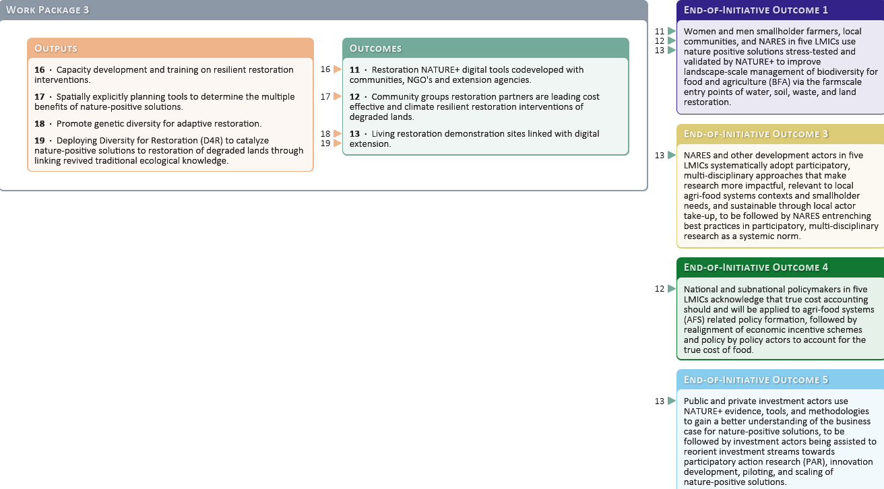

**Progress against the theory of change**

WP3 played a crucial role in restoring degraded landscapes through innovative restoration tools, participatory approaches, and integrated watershed management. By combining scientific research with community-driven efforts, the NATURE+ strengthened ecosystem resilience and contributed to climate adaptation in diverse agricultural landscapes.

**Work Package 4: RECYCLE**

Theory of change diagram:

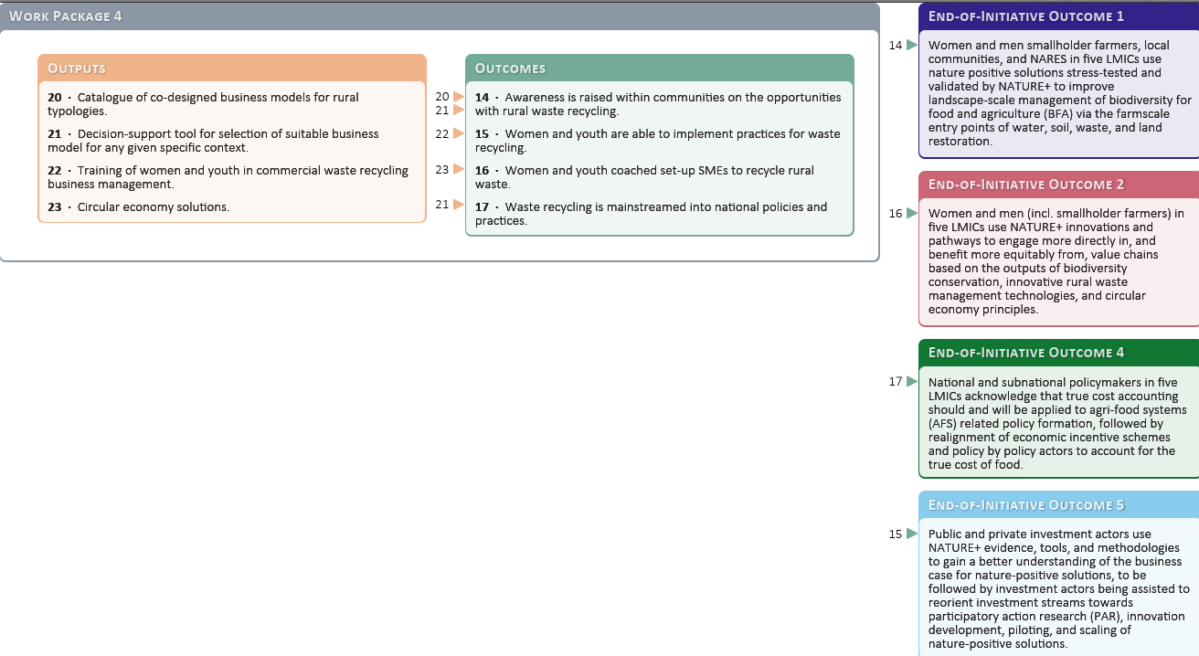

**Progress against the theory of change**

WP4 drove the adoption of circular bioeconomy solutions by promoting sustainable waste management, innovative bio-based models, and nature-positive income-generating activities. These efforts supported both environmental sustainability and economic resilience in local communities.

**Work Package 5: ENGAGE**

Theory of change diagram:

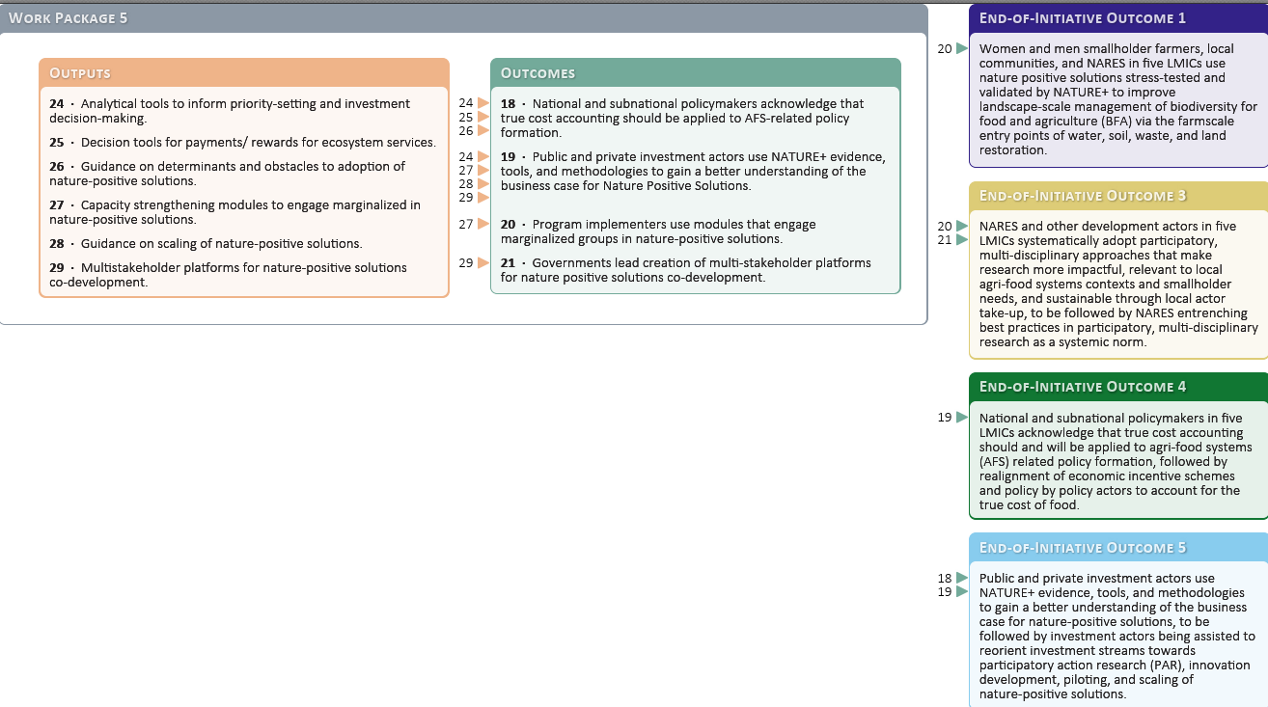

**Progress against the theory of change**

WP5 strengthened engagement with policymakers, communities, and research institutions to promote the adoption of nature-positive solutions. By using participatory approaches, evidence-based advocacy, and innovative learning tools, the Initiative fostered a stronger policy environment for sustainable agriculture.

**Country-specific achievements**

*Viet Nam:*

* Genetic gap analysis for detecting unique landraces of traditional crops was conducted for populations of taro, banana, and potato, both in situ and ex situ; citizen science collaboration undertaken for agrobiodiversity conservation (WP1).
* Traditional crops were successfully integrated into value chains, improving food and nutrition security. Value chain women groups as well as health groups were established and active to sell organic vegetables (WP2).
* Soil degradation was addressed through sustainable agricultural practices and landscape restoration efforts (WP3).
* NATURE+ supported **c**ircular bioeconomy practices, promoting the sustainable use of agricultural waste. In particular, training program on circular economy models for the coffee and rice value chains. [An MoU with UNDP](https://www.undp.org/vietnam/press-releases/joint-initiative-upgrade-agricultural-circular-businesses-viet-nam) was signed, nationally integrating N+ in circular economy (WP4).
* [Research on the true cost of food production](https://hdl.handle.net/10568/163385) provided valuable insights into sustainability trade-offs (WP5).

*Kenya:*

* Extended evaluation of NUS and crop genetic diversity for inclusion in production systems as well as traditional vegetable. Strengthening of community seed banks (WP1).
* aggregated farms that encompass all NATURE+ WPs; support for growth of [community seed banks and resilient seed system](https://www.cgiar.org/news-events/news/building-nature-positive-seed-systems-for-community-seed-banks-in-kenya-and-india) (WP2).
* A [digital app was introduced](https://alliancebioversityciat.org/stories/tree-tech-growing-more-resilient-future) to guide farmers in native-tree reforestation, with financial incentives tied to successful tree establishment (WP3).
* The [MyFarmTrees](https://myfarmtrees.org/) forest restoration app expanded to integrate circular bioeconomy principles, encouraging farmers to adopt sustainable practices. In addition, the Initiative aaccelerated circular innovations by convening [country-wide networks of circular bioeconomy](https://www.cgiar.org/research/publication/agritech4kenya-innovation-challenge-2024-bootcamp-highlight) entrepreneurs for capacity-building, innovation challenges and increasing collaboration with government entities tasked with increasing sustainable economic activity (WP4).
* Community engagement was enhanced through games-based research, facilitating knowledge exchange and adoption of nature-positive practices. [The true cost of food was assessed in Kenya](https://hdl.handle.net/10568/152074) (WP5).

*India:*

* Tribal communities in Maharashtra benefited from strengthened traditional seed banks and the integration of indigenous knowledge into sustainable agricultural systems. on-farm conservation centers; community seed bank establishment (WP1).
* Traditional knowledge was harnessed to support indigenous seed banks and integrated watershed management, strengthening sustainable agriculture (WP2)..
* Integrated watershed management systems were implemented, linking water conservation with ecosystem restoration (WP3).
* [A national hub for circular bioeconomy was launched](https://www.cgiar.org/news-events/news/nature-launches-circular-bioeconomy-hub-in-india-to-inspire-innovate-and-integrate-nature-positive-businesses/), combining traditional knowledge with modern sustainability science (WP4).
* Gender-specific studies informed strategies to improve the adoption of sustainable farming practices by women farmers (WP5).

*Colombia:*

* establishment of a community seed bank in Indigenous Andean community for improved access to NUS; transition from extractive dairy production to nature-based agriculture; collaboration with Colombia's agriculture research organization, Agrosavia, (WP1).
* Farmers transitioned from extractive farming practices to nature-positive models, increasing long-term sustainability. agro-ecotourism and value chain development; [transition toward nature-positive livestock systems in biodiversity hotspots (WP2).](https://hdl.handle.net/10568/138719)
* A shift to nature-positive farming contributed to restoring degraded landscapes and improving soil health (WP3).
* Nature-positive startup incubators helped scale up sustainable business models in the [bioeconomy](https://www.cgiar.org/news-events/news/cgiar-initiative-nature-unites-circular-economy-entrepreneurs-in-colombia/) sector and convened a country-wide [innovation challenge](https://agritechchallenge.org/projects/circulareconomy-4colombia) (WP4).
* Multistakeholder dialogues influenced policy decisions related to nature-positive agriculture (WP5).

*Burkina Faso:*

* development of [seasonal calendars to map neglected and underutilized crop species (NUS)](https://hdl.handle.net/10568/138539) (WP1).
* women’s empowerment through the use of neglected and underutilized species (NUS). By revitalizing local women’s groups and upgrading processing facilities, the project enhances food security, economic opportunities, and community cohesion. It also develops attractive branding for NUS-based products to boost market (WP2).
* Collaboration to implement new frameworks for restoring agricultural landscapes, including among [women’s group](https://www.cgiar.org/news-events/news/571768-autosave-v1/) for better market access and [schools](https://hdl.handle.net/10568/152237) (WP3).
* Capacity building on CBE practices such as biofertilizer and biochar production; waste-to-energy solutions (WP4).
* Community-based approaches improved local governance frameworks for sustainability efforts (WP5).

**2024 Highlights**

In 2024, WP1 made notable progress toward its theory of change by strengthening traditional and community seed banks across multiple regions, ensuring the continued conservation and use of agrobiodiversity. The Initiative also advanced the development and enhancement of digital platforms that promote biodiversity in agriculture, including [Wikipapa](https://wikipapa.org), [RIKIYU-Agrobio](https://rikiyu.org), [EncontrAR](https://encontrar.info), and [VarScout](https://varscout.org). These tools have expanded access to information and facilitated decision-making for farmers and researchers alike. Additionally, WP1 successfully enhanced the integration of neglected and underutilized species (NUS) into food systems, further diversifying diets and strengthening resilience across implementation sites.

In 2024, WP2 contributed significantly to its theory of change by improving food and nutrition security through sustainable crop diversification and expanded access to diverse planting materials via community seed banks. The Initiative also strengthened market access for biodiversity-friendly products, helping farmers link nature-positive practices with economic opportunities. At the same time, WP2 enhanced farmer-led innovation, supporting locally adapted solutions that promote resilient, nature-positive agriculture across diverse contexts.

In 2024, WP3 successfully implemented digital tools for reforestation, enabling more effective planning and monitoring of restoration activities. The Initiative expanded integrated watershed management systems, improving landscape functionality and resilience. Community-led restoration efforts also gained momentum, with strengthened local engagement driving sustainable practices across degraded landscapes.

In 2024, WP4 accelerated progress on circular bioeconomy goals by expanding bioeconomy hubs and startup incubators that support innovation and entrepreneurship. The Initiative worked with stakeholders to integrate circular bioeconomy principles into national sustainability frameworks, reinforcing long-term policy alignment. At the community level, participation in waste-to-resource initiatives grew stronger, demonstrating increased local ownership of nature-positive, circular solutions.

In 2024, WP5 deepened its policy and engagement work by generating true cost accounting data that informed policymakers about the real costs of food, enabling the design of more sustainable, equitable, and health-focused food systems. The Initiative also saw wider adoption of participatory learning tools, which strengthened knowledge-sharing and collective problem-solving among stakeholders. In parallel, it enhanced gender-responsive approaches, ensuring that nature-positive agriculture reflects and supports the needs and contributions of women and other marginalized groups.

**Progress ratings**

*WP1: On track*. The conservation of agrobiodiversity advanced through the establishment of community seed banks in multiple regions, ensuring genetic diversity preservation. Successes include increased farmer engagement in nature-positive practices and strengthened cooperative models. Ongoing efforts focus on expanding resilient value chains and addressing market access challenges.

*WP2: On track*. WP2 successfully integrated sustainable agricultural biodiversity use into local food systems, improving nutrition and economic opportunities. Key achievements include the promotion of neglected and underutilized species (NUS) and the adoption of nature-positive farming techniques.

*WP3: On track*. NATURE+ made significant progress in landscape restoration through tools like [Diversity for Restoration (D4R)](https://www.diversityforrestoration.org/) and [MyFarmTrees](https://myfarmtrees.org/), enabling better decision-making for biodiversity recovery and farm- and landscape-scale restoration. Training programs in circular economy models strengthened sustainable agricultural value chains. Securing long-term funding, deepening multistakeholder engagement and expanding to additional countries under the CGIAR Research Portfolio 2025-2030.

*WP4: On track*. The work on circular bioeconomy (CBE) gained traction, with women-led cooperatives successfully producing briquettes from organic waste, offering economic and environmental benefits. Additionally, Black Soldier Fly (BSF) farming was widely promoted for sustainable animal feed solutions and for fertilizer production. Scaling up these innovations and embedding them into broader policy frameworks is the goal for continued CBE expansion in the CGIAR research portfolio.

*WP5: On track*. True Cost Accounting research and gender-responsive adoption of nature-positive practices strengthened policy engagement to create enabling conditions for increased nature-positive activities. Innovative community engagement methods, such as games-based research in Kenya, facilitated knowledge-sharing and behavior change. Scaling policy uptake and deepening gender-inclusive approaches will be prioritized in future work.

**Header: Work Package progress rating**

*Select one rating and add rationale aligned with evidence.*

|  |  |  |  |
| --- | --- | --- | --- |
| Work Package | Traffic light | Progress rating | Rationale |
| 1 | Green | On track | Agrobiodiversity conservation advanced through community seed banks, strengthening genetic diversity preservation and farmer engagement in nature-positive practices. |
| 2 | Green | On track | Sustainable agricultural biodiversity use was successfully integrated into food systems, improving nutrition, economic opportunities, and the promotion of neglected and underutilized species. |
| 3 | Green | On track | Landscape restoration made significant strides with tools like Diversity for Restoration (D4R) and My Farm Trees. |
| 4 | Green | On track | Circular bioeconomy solutions, such as women-led cooperatives producing briquettes from agricultural waste and Black Soldier Fly (BSF) farming, gained strong momentum. |
| 5 | Green | On track | Policy and community engagement were strengthened through research on the true cost of food production and gender-responsive adoption of nature-positive practices. |

**Section 4: Quantitative overview of key results**

This section provides an overview of results reported by the CGIAR Research Initiative on Nature-Positive Solutions from 2022 to 2024. These results align with the CGIAR Results Framework and NATURE+'s theory of change. Further information on these results is available through the CGIAR Results Dashboard.

The data used to create the graphics in this section were sourced from the CGIAR Results Dashboard on 13 March, 2025. These results are accurate as of this date and may differ from information in previous Technical Reports. Such differences may be due to data updates throughout the reporting year, revisions to previously reported results, or updates to the theory of change.

**Table 1 Results by Region:** this table provides an overview of the geographical spread of results achieved under the Nature-Positive Solutions Initiative from 2022 to 2024. It highlights the diverse country contexts—Viet Nam, Kenya, India, Colombia, and Burkina Faso—where the Initiative's science, innovations, and partnerships have contributed to tangible outcomes across conservation, restoration, circular bioeconomy, sustainable management, and policy engagement. While implementation was focused in five target countries, several results—particularly knowledge products, tools, and policy contributions—have extended beyond these geographies, demonstrating the Initiative’s broader global relevance and potential for scaling.

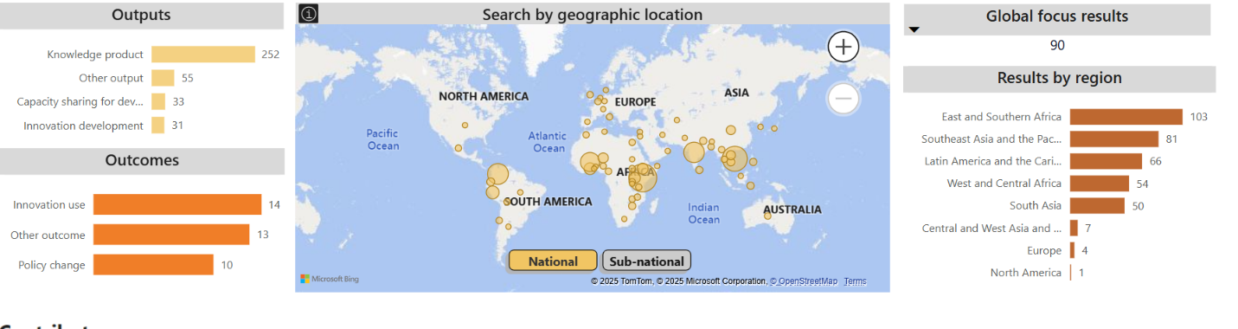

**Table 2 Capacity Sharing for Development work:** this table summarises the Initiative’s contributions to capacity sharing for development between 2022 and 2024, with 33 documented results engaging over 15,000 individuals across stakeholder groups, a majority of whom are women. These efforts included technical trainings, community-led demonstrations, participatory research, and innovation uptake activities tailored to local needs. Capacity sharing has been central to the Initiative’s strategy for enabling locally driven, sustainable transitions to nature-positive food systems.

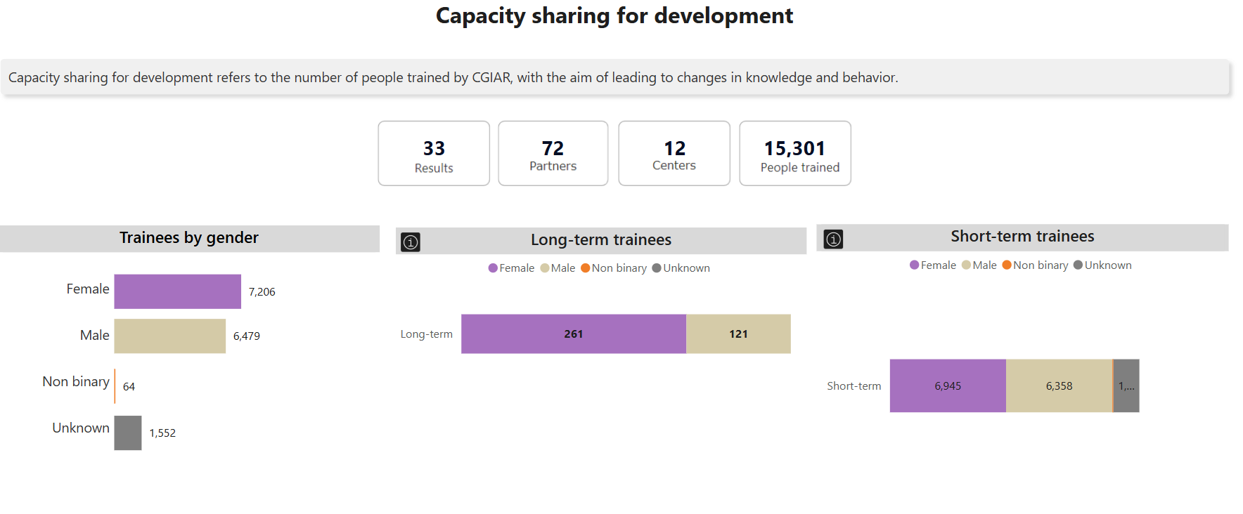

**Table 3 and 4 Policy Change work:** NATURE+ engaged policymakers at local, national, and global levels to integrate biodiversity and sustainability into agricultural and food system policies. Through tools like true cost accounting, gender-responsive analysis, and stakeholder dialogues, the Initiative informed evidence-based decision-making in all five target countries. Its contributions have shaped policy reforms, supported national strategies, and influenced global conversations on nature-positive agriculture. An agroecology policy informed by NATURE+ was approved by Vihiga County in Kenya.

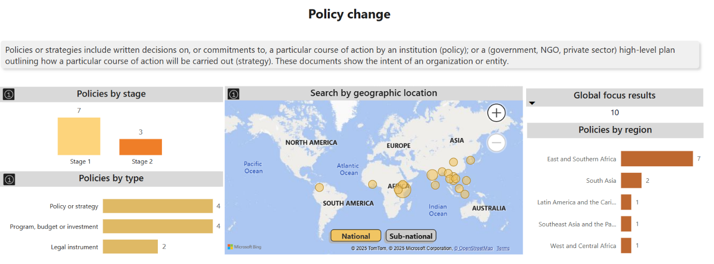

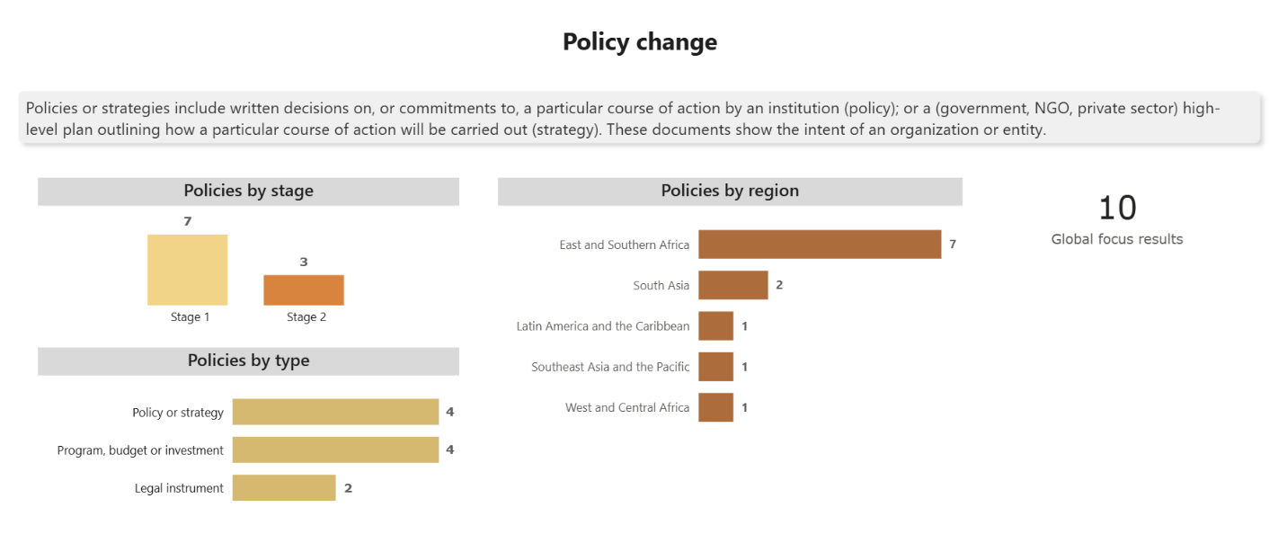

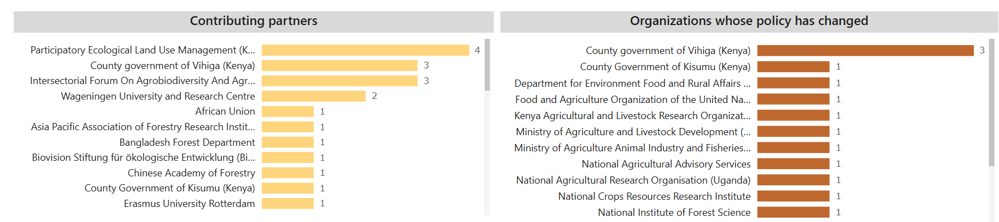

**Table 5 and 6 Contributing Partners:** The tables present the key external (non-CGIAR) partners that have contributed to the Nature-Positive Solutions Initiative between 2022 and 2024. Partnerships span government agencies, national research systems, civil society organizations, Indigenous groups, the private sector, and international development actors. These collaborations have been instrumental in co-designing innovations, scaling adoption, influencing policy, and ensuring that nature-positive solutions are grounded in local realities and institutionalised for long-term impact.

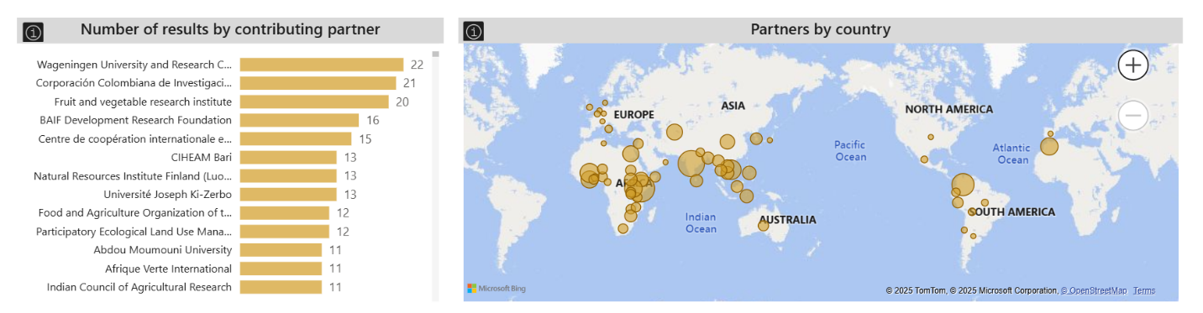

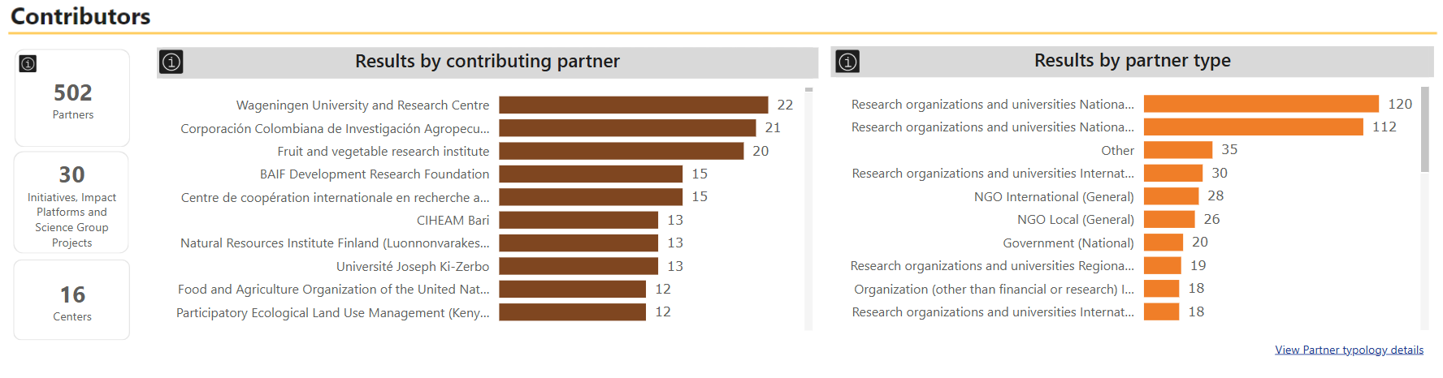

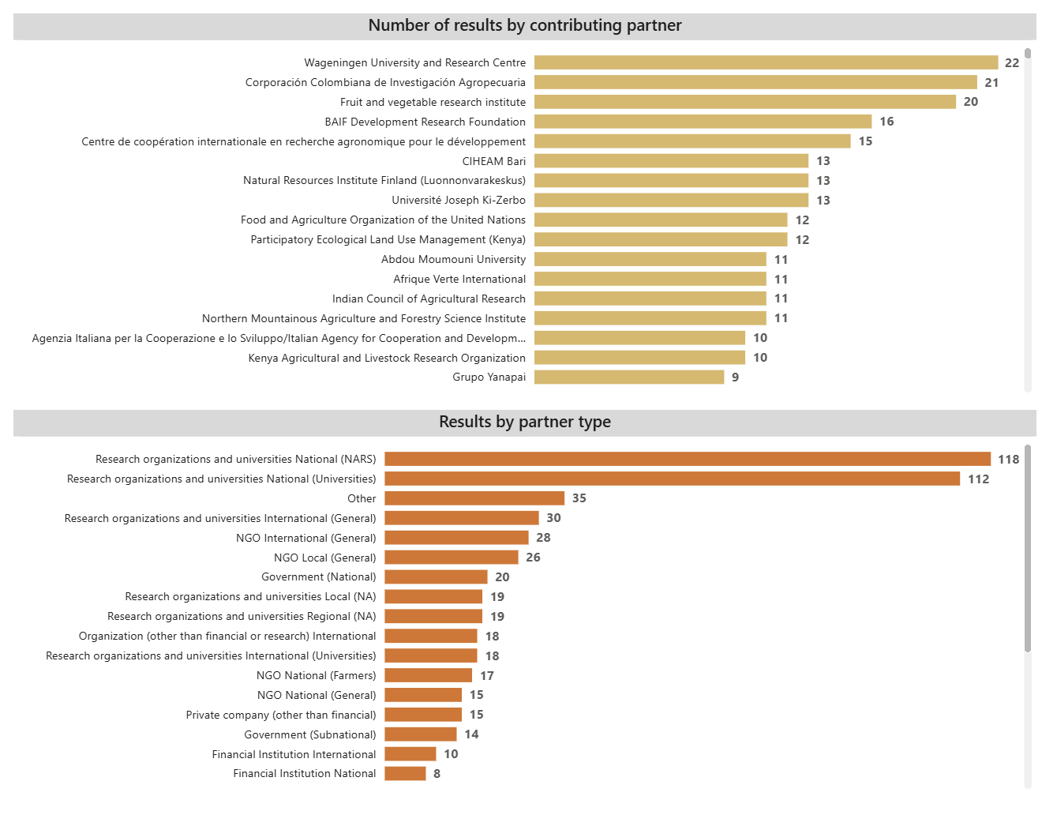

**Table 7 Innovation Use:** This table captures the range of innovations developed or applied through the Nature-Positive Solutions Initiative between 2022 and 2024. It includes digital tools, restoration planning frameworks, circular bioeconomy models, and participatory methodologies that have been adopted by farmers, researchers, and policy actors.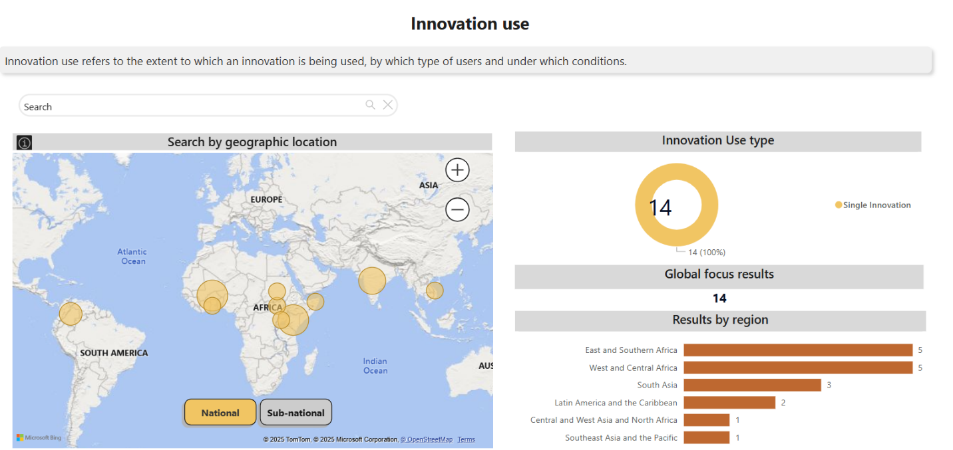

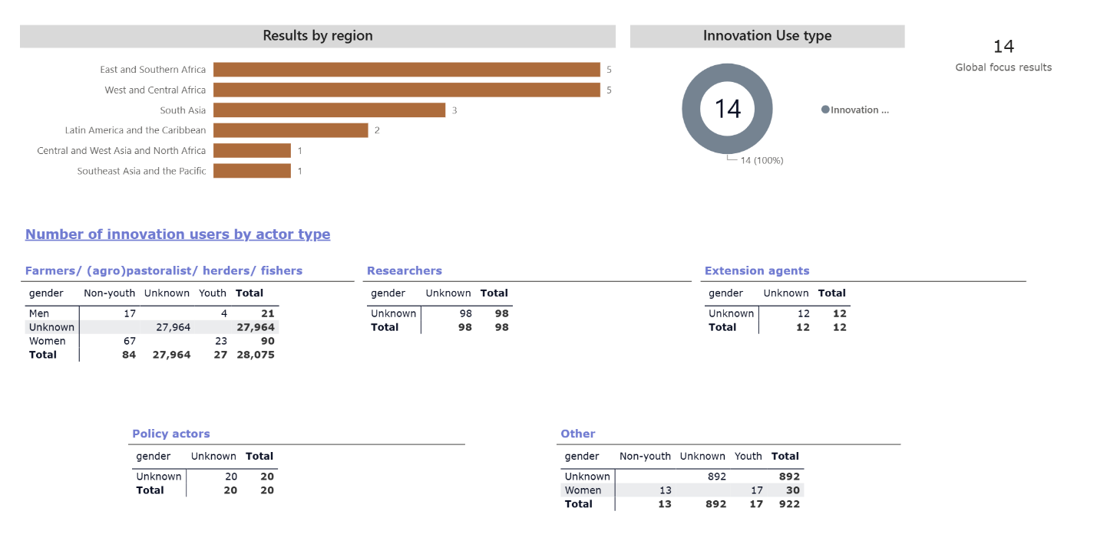

**Section 5: Partnerships**

Photo for section 5

Option 1: [Jai Rana at Agoro community seedbank.jpeg](https://cgiar.sharepoint.com/:i:/r/sites/InitiativeDesignTeams/Shared%20Documents/Type%201%20Reports_2024/INIT12_Nature-Positive%20Solutions/Jai%20Rana%20at%20Agoro%20community%20seedbank.jpeg?csf=1&web=1&e=9UgUr1)

Evelyn Okoth (left), discusses her community’s seedbank Kisumu County, Kenya, with Jai Rana (right), the India Country Representative for the Alliance of Bioversity International and CIAT. Okoth leads a women’s group in her community that collaborated closely with NATURE+ on the implementation of nature-positive agriculture. Partnerships with local community organizations were key to the Initiative’s successes across its five target countries.

Credit: Sean Mattson/NATURE+, Alliance of Bioversity International and CIAT

**Partnerships and NATURE+ impact pathways**

Partnerships were at the core of NATURE+. Their expertise and site-specific knowledge played a critical role in scaling innovations, implementing nature-positive agricultural practices, and driving policy and investment change. The Initiative collaborated with a diverse network of **research institutions, international Organizations, national and local governments, farmer organizations, private sector actors, and civil society groups** to ensure that nature-positive approaches are effectively integrated into food systems and landscapes.

The theory of change guiding the Initiative emphasized cross-sector collaboration to achieve meaningful progress toward the End of Initiative Outcomes (EOIOs). Partnerships supported key areas such as knowledge co-creation, capacity building, policy uptake, and investment mobilization, ensuring that nature-positive solutions are both scientifically grounded and implementable at scale.

These collaborations facilitated the implementation of participatory research approaches, strengthened farmer-led innovation, and provided critical financial and technical resources to sustain long-term adoption of biodiversity-enhancing practices. Many of these partnerships evolved into sustained collaborations, ensuring that the Initiative’s impact extends beyond the CGIAR business cycle.

**Partnership Landscape and Key Contributions**

The Initiative has engaged with a broad range of external (non-CGIAR) partners, including:

* **National Agricultural Research and Extension Systems (NARES)** to drive localized research and adoption of nature-positive solutions.
* **Government agencies** in Kenya, Viet Nam, Colombia, India, and Burkina Faso, influencing policy frameworks that integrate biodiversity into national agricultural strategies.
* **Farmer cooperatives and local community organizations**, ensuring that smallholder farmers are both beneficiaries and co-creators of innovations.
* **Private sector actors**, including agribusinesses and impact investors to support market access and financial sustainability for nature-positive products.
* **International NGOs and UN agencies**, helping integrate the Initiative’s work into global sustainability agendas.

Across all WPs, partnerships were instrumental in translating research into action. Notably, collaborations with investment actors—particularly in Kenya and Colombia— led to the mainstreaming of nature-positive financial frameworks, as demonstrated by efforts to integrate biodiversity incentives into national agricultural policies. Simultaneously, policy-focused partnerships supported evidence-based decision-making, with India, Viet Nam, and Burkina Faso leveraging multistakeholder dialogues to embed nature-positive principles into governance frameworks

**2024 Highlights**

In 2024, partnerships continued to drive momentum for nature-positive transitions. Some key highlights include:

* **Kenya & Colombia**: Collaborations with national policymakers and financial institutions resulted in the integration of nature-positive principles into national agricultural policies and incentive structures.
* **India**: The Initiative worked closely with tribal communities and local research organizations, strengthening traditional seed banks and advancing agrobiodiversity conservation.
* **Viet Nam**: Engagement with local and rural farming networks led to the successful promotion of traditional crops within sustainable value chains.
* **Burkina Faso**: A multistakeholder collaboration between women’s groups, local schools, and research institutions supported the establishment of new agroecological research frameworks to improve climate resilience.
* **Regional & Global Level**: The Initiative participated in global policy dialogues with organizations such as FAO, UNDP and UNEP, ensuring that nature-positive solutions are reflected in international sustainability frameworks.

**Strategic Partnership Example: CGIAR–World Bank Partnership Synthesis Report: Advancing Nature-Positive Agriculture**

Researchers from four CGIAR Centers—the Alliance of Bioversity International and CIAT, IFPRI, IWMI, and CIP—along with Wageningen University, partnered with the World Bank to produce the CGIAR–World Bank synthesis report on advancing nature-positive agriculture. The report presents a strategic and actionable framework for transitioning to nature-positive agriculture by directly addressing the negative impacts of agricultural production on biodiversity and ecosystem services—thereby contributing to climate change mitigation and building a more resilient and sustainable global food system. Recognizing that agricultural transformation must go beyond isolated interventions, the report emphasizes a system-level approach that integrates bundles of nature-positive practices with a clear assessment of the enabling environment needed to drive agricultural transitions. The collaboration between CGIAR and the World Bank bridges global environmental goals with local agricultural and social realities, where CGIAR science and innovations play a pivotal role in supporting World Bank and government investments. Working closely with the World Bank, the team showcased spatially targeted, evidence-based guidance aligned with national biodiversity strategies and Sustainable Development Goals (SDGs) in countries such as Colombia and Ghana. The report offers a blueprint for investment and policy action toward nature-positive agriculture—building urgently needed connections between biodiversity conservation, food system resilience, and rural development.

These partnership provided alternative income sources for marginalized groups and contributed to improved waste management, biodiversity conservation, and climate resilience. The success of these models has generated interest from policymakers and impact investors, creating opportunities for further expansion beyond the Initiative’s timeline.

NATURE+ demonstrated that strong partnerships—across research, policy, finance, and local implementation—are essential for achieving lasting sustainability impacts. By fostering collaborative networks that bridge science and practice, the Initiative laid the foundation for continued adoption of nature-positive agricultural and economic research and model implementation beyond 2024.

Moving forward, sustaining and expanding partnerships will be critical to ensure that the progress made over the past three years is institutionalized, scaled, and adapted to diverse contexts globally. The partnerships built through this Initiative serve as a blueprint for how multistakeholder collaboration can drive systemic change toward a more resilient and biodiversity-friendly future.

**Section 6: CGIAR Portfolio linkages**

The Initiative is well integrated within the CGIAR Initiative portfolio. NATURE+’s collaboration with the CGIAR Research Initiatives on Agroecology, Nexus Gains, Low-Emission Food Systems, and Gender Equality continued to grow, as sustainable intensification and excellence in agronomy are both critical to define pathways and a framework toward achieving more sustainable agriculture and reducing the negative impacts generated by it. NATURE+ also linked with the CGIAR Research Initiatives on Mixed Farming Systems, Livestock and Climate, Resilient Cities, as well as the CGIAR Gender Impact Platform to best develop circular economy strategies, which form a significant part of the Initiative. Finally, NATURE+ engaged in areas of collaboration with the CGIAR Research Initiatives on Seed Equal and Genebanks on the use of genetic resources. With the Genebanks Initiative, NATURE+ explored ways to link in situ and ex situ conservation and improve the use of genetic resources conserved in genebanks.

**Section 7: Key result story**

Title:

NATURE+ circular bioeconomy activities reach more than 5,000 people

Photo:[CO7_CIRCULAR-ECONOMY.jpg](https://cgiar.sharepoint.com/:i:/r/sites/InitiativeDesignTeams/Shared%20Documents/Type%201%20Reports_2024/INIT12_Nature-Positive%20Solutions/CO7_CIRCULAR-ECONOMY.jpg?csf=1&web=1&e=Z35Jre)

Caption for KRS photo:

Caption: Researchers at the Alliance of Bioversity International and CIAT work at the Black Soldier Fly (BSF) research lab at the Alliance campus in Palmira, Colombia. BSF farming rapidly transforms organic food waste into compost and excess BSF larvae is processed into an ingredient high-protein animal feed. BSF farming reduces waste, reducing greenhouse gas emissions; reduces feed and fertilizer costs for farmers since it reduces reliance on industrial and often environmentally unfriendly inputs; helps restore degraded landscapes; and creates economic opportunities for BSF farmers. NATURE+ widely deployed the low-cost, easy-to-implement technique at research sites.

Credit: Douglas Gayeton/The Lexicon. Non-commercial use allowed with attribution.

*Outcome statement*

By 2024, the NATURE+ Initiative’s circular bioeconomy activity reached dozens of communities in five countries, creating or enhancing sustainable income sources. This shows that the Initiative’s RECYCLE WP created wins for both people and nature, embodying the ethos of the Initiative.

Summary

NATURE+ scaled circular bioeconomy innovations, empowering communities—especially women—to convert agricultural waste into income, restoration, and resilience as part of a transition toward more nature positive systems.

Geographic Location:

Burkina Faso, Colombia, India, Kenya, Viet Nam, Ghana

**Waste Not**

**Quote**: “The transition toward nature-positive agriculture requires several simultaneous, often paradigm-challenging actions. These include innovations for the conservation, management, and restoration of biodiversity—especially agricultural biodiversity. Additionally, producers need policies, accessible research, and evidence-based, professional support to reduce reliance on costly industrial inputs that often underperform on degraded lands and contribute to further land degradation.

To complete the nature-positive circle, circular bioeconomic action is crucial.” said Dr. Carlo Fadda, the Initiative lead. This is why the CGIAR Nature-Positive Solutions Initiative (NATURE+) prioritized research and implementation on circularity. Like all NATURE+ WPs, circularity was interlinked with the Initiative’s broader efforts to promote and scale nature-positive transitions.

From coffee bean husks in Colombia to rice stems in Viet Nam, organic agricultural waste is a common challenge in all NATURE+ sites. Though some communities manage waste well, most treat it as a nuisance. When unmanaged, the scale of waste in the Global South is staggering. But properly handled, agricultural waste can become fertilizer, animal feed, or energy—and generate rural income. At scale, circular bioeconomy models benefit both people and ecosystems.

**Quote**: “There is huge potential for circular bioeconomies in the Global South. Unfortunately, it’s still mostly untapped. But NATURE+ laid robust foundations for circularity in the communities across the five countries where we worked,” said Solomie Gebrezgabher, who led the RECYCLE WP.

**Crop Circles**

Gebrezgabher and the RECYCLE team began by assessing [circular bioeconomy](https://hdl.handle.net/10568/144219) (CBE) potential in Burkina Faso, Colombia, India, Kenya, and Viet Nam. They shared results with communities to identify locally relevant CBE models. Between 2022 and 2024, NATURE+ established circular bioeconomy hubs in Ghana, India, and Viet Nam and hosted innovation challenges in Colombia and Kenya. In Colombia, these were paired with boot camps for entrepreneurs, which built a national network of like-minded businesses. Several were selected for CGIAR’s Accelerate for Impact Platform.

NATURE+ also implemented Black Soldier Fly (BSF) farming systems in Colombia, India, and Kenya. These systems convert organic waste into compost (frass) and nutrient-rich fly larvae used as animal feed. A BSF installation at an aggregated farm in Kenya—another NATURE+ innovation—became a central feature of the farm’s production and restoration efforts. In India, NATURE+ launched biochar projects, supporting soil health with organic "coal."

More than 5,000 people participated in these growing circularity efforts. In addition to fieldwork, the Initiative published studies to address knowledge gaps on circularity in the Global South and inform policy proposals to create more enabling environments for circular economies.

**Quote**: “NATURE+ demonstrated that circular bioeconomies successfully contribute to conservation, restoration and livelihoods,” Gebrezgabher said.

**Closing the Loop**

In Kenya, NATURE+ helped 30 women form a cooperative to produce briquettes from organic waste, providing training and equipment. The cooperative now operates independently and produces higher-quality products. In India, a women's group producing biochar similarly became a self-sustaining business. In Viet Nam, NATURE+ partnered with UNDP to develop circular bioeconomy models for coffee and rice value chains.

**Quote**: “UNDP was initially focused on plastic and industrial waste, not necessarily agricultural waste,” Gebrezgabher said. “We filled that gap for them.”

While circularity interventions must be tailored to local contexts—for instance, Viet Nam prioritized rice and coffee waste over BSF—common threads emerged. Women’s groups showed strong interest in circular economy practices, and many recycling activities, though widespread, remained informal. Formalizing these practices could improve safety, scalability, and profitability.

**Challenges and Potential**

Challenges remain. Start-ups often struggle to secure financing. A lack of product standards can reduce quality and harm credibility. Regulatory support is limited. And co-designing with communities takes time, though it significantly boosts success.

Still, NATURE+ and its partners see circular bioeconomy practices expanding from farm to landscape scale. One strategy involves returning value-added waste (e.g., compost, biochar, feed, energy) to rural areas from which agricultural products are extracted, effectively closing the loop. By reducing waste, replenishing soils, and lowering dependence on industrial inputs, circular bioeconomy practices help conserve biodiversity, restore degraded land, and build resilient landscapes.

**Quote**: “This is what it means to have a circular economy at a landscape level,” Gebrezgabher said.

*Section: Result title as entered in PRMS – for internal use*

*Comment for PPU: The result is not tagged as a KRS in PRMS*

*Section: Contact persons – for internal use*

Technical contact point

Name: Gebrezgabher, Solomie

Role: Senior Researcher

Center: IWMI

Email: [S.Gebrezgabher@cgiar.org](mailto:S.Gebrezgabher@cgiar.org)

Communications contact point

Name: Mattson, Sean

Role: Communication Officer

Center: ABC

Email: [S.Mattson@cgiar.org](mailto:S.Mattson@cgiar.org)